**Program 13: Demonstrate abstract base class implementation and usage**

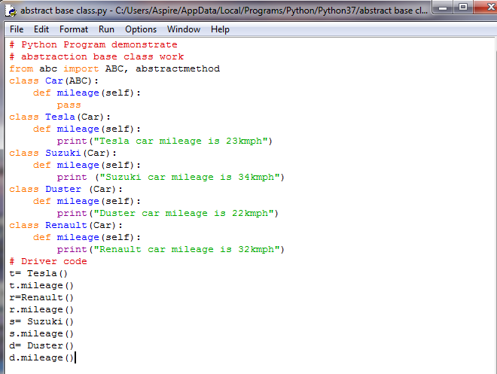

**Output:**

